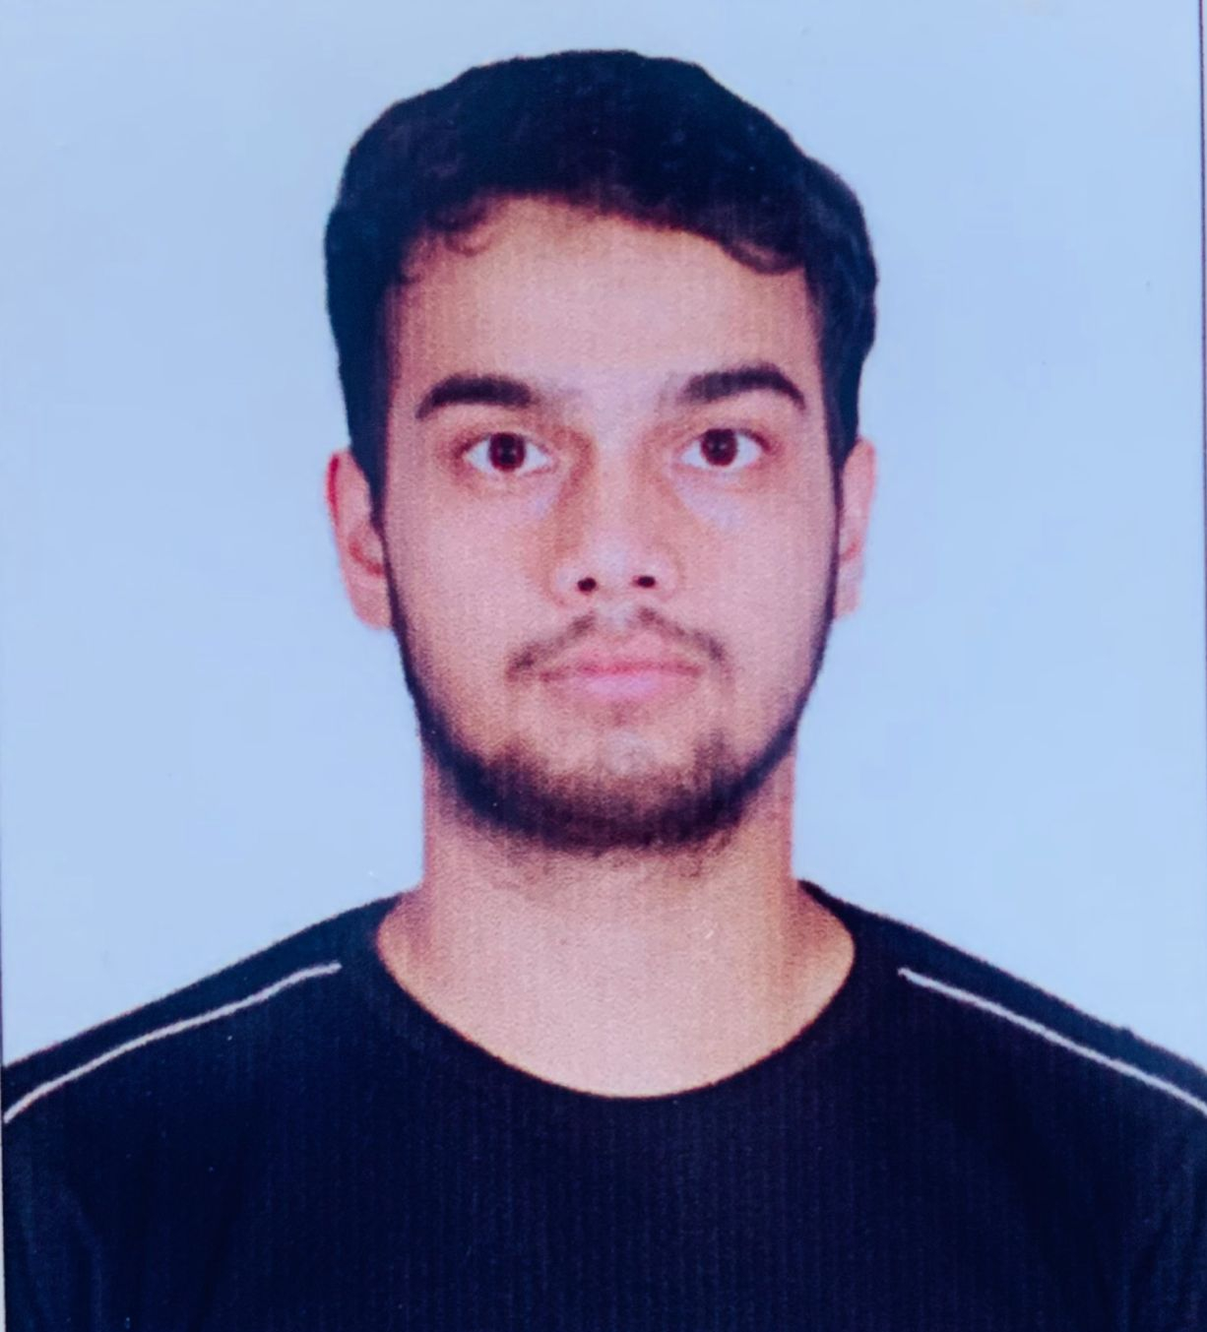

**EDUCATION**

Master of Computer Application | SHARDA UNIVERSITY, Greater Noida

Session: 2022 - 2024 | Pursuing now

Bachelors in Science | RK,PG COLLEGE, Shamli

*Session: 2019-2022 | Score: 56%*

Intermediate (CBSE) |Mother Land Public School, Shamli

*Session: 2018-2019| Percentage: 70%*

Matriculation (CBSE) | Mother Land Public School, Shamli

*Session: 2017-2018 | Percentage: 72.2%*

**PROJECTS & INTERNSHIPS**

Project Title 1

Synopsis: PRODUCT PRICE TRACKER

Project Title 2

Synopsis: tic tac toe

**CERTIFICATIONS &AWARDS**

**. Bootcamp as a student of Anonymous club of Technovt Society**

**. C and C++ Certificate**

**EXTRA CURRICULAR & CO-CURRICULAR ACHIEVEMENTS**

* 5 km Marathon race dated 21 September 2019
* Football player

**RAJAT DIXIT**

LinkedIn: www.linkedin.com/in/rajat-dixit-111410255

Email: rajatdixit9552@gmail.com

Contact: +91 –8273006462

**PROFESSIONAL SUMMARY**

A well-organized, creative and goal-oriented graduate possessing excellent communication, problem-solving and leadership skills with a flair to explore suitable avenues in Computer Science Engineering while developing advanced projects with efficiency and quality.

**TECHNICAL COMPETENCIES**

PYTHON | C++ | HTML | CSS | JAVASCRIPT | JAVA |

**INTERPERSONAL SKILLS**

Team Leadership **|** Management & Coordination **|** Decision Making

**INTERESTS & HOBBIES**

Writing **|** football **|** Painting **|** Travelling **|**

**LANGUAGES KNOWN**

English **|** Hindi